Introduction :

Three-wheeler registration is an essential legal process that ensures the ownership, compliance, and proper documentation of three-wheeled vehicles, including auto-rickshaws, e-rickshaws, and cargo carriers.

This registration, mandated by government transport authorities, involves assigning a unique registration number and issuing a registration certificate. The primary objectives of three-wheeler registration include providing legal authorization to operate on public roads, verifying vehicle ownership, ensuring compliance with tax and insurance regulations, aiding in traffic law enforcement, and adhering to environmental and safety standards.

The registration process generally involves submitting necessary documents such as proof of purchase, identity and address verification, and vehicle insurance details, followed by an inspection conducted by the transport department. Upon successful verification, the authorities issue the registration certificate and license plate.

Proper registration not only grants legal protection to the owner but also plays a significant role in maintaining an organized and regulated transportation system.

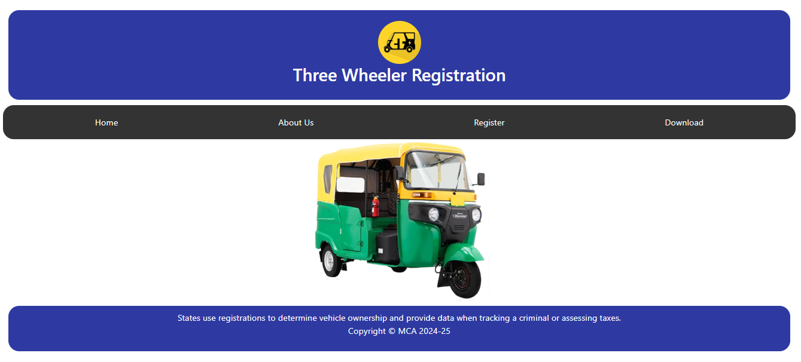

*Figure 1: Home page*

The **Three Wheeler Registration** platform provides a simple and user-friendly interface where users can register, access information, and download necessary documents related to vehicle registration. With an intuitive layout, navigation is easy for all users, and features are clearly organized for vehicle owners and authorities. Users receive updates about registration status, renewal reminders, and essential guidelines. A search tool helps locate nearby registration offices and check application requirements. The homepage includes useful information on the registration process, required documents, and legal compliance, while a dashboard highlights registered vehicle statistics and important announcements. User data is kept secure, and all interactions remain confidential. As shown in ***Figure 1: Home Page***, the system effectively brings these features together in a clean, accessible design.

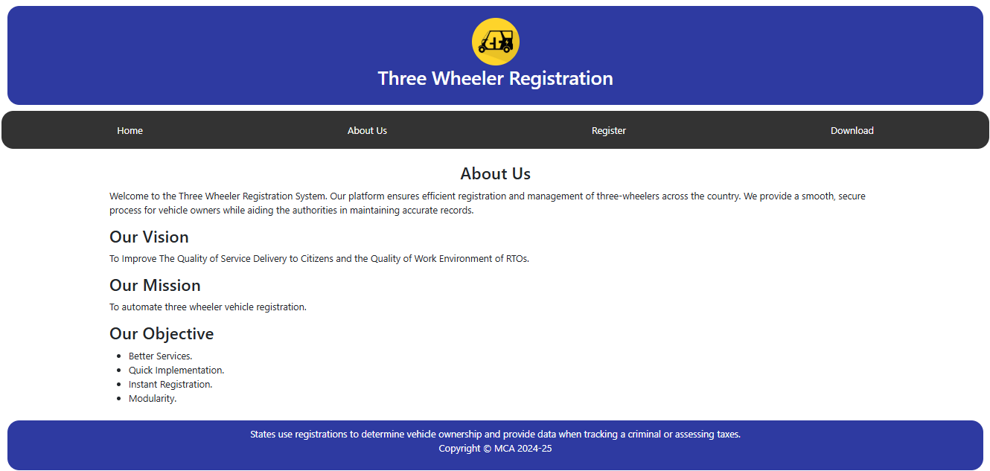

*Figure 2: About-Us*

The About Us page of the Three Wheeler Registration system provides essential information about the platform’s purpose, vision, mission, and objectives. It ensures users understand the system's role in managing and streamlining the registration process for three-wheelers while assisting authorities in maintaining accurate vehicle records. ***Figure 2: About-Us*** illustrates the structure and content of this section, offering a visual representation of how the information is organized and presented. The About Us section starts with a brief introduction explaining the platform’s purpose—providing an efficient, secure, and smooth registration process for three-wheeler owners and regulatory authorities. The page further highlights the Vision, Mission, and Objectives of the system:

* Vision: Aims to enhance service delivery quality for citizens and improve the work environment of Regional Transport Offices (RTOs).
* Mission: Focuses on automating the three-wheeler registration process.
* Objectives: Includes goals such as better services, quick implementation, instant registration, and modularity.

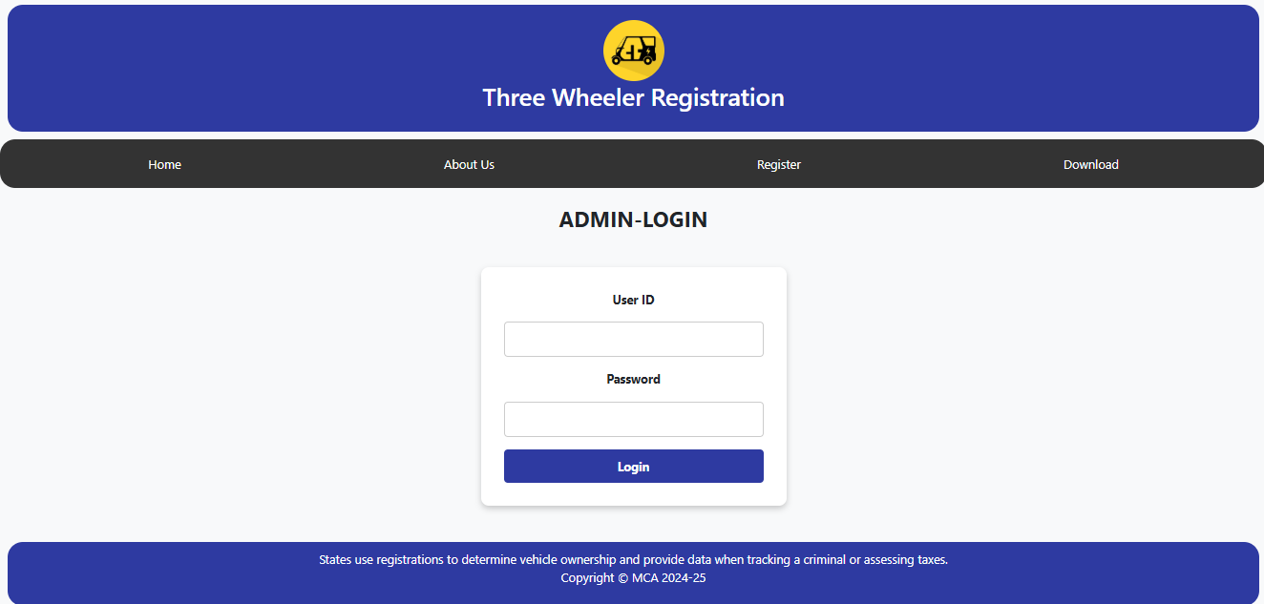

*Figure 3: Admin-Login Page*

The Admin Login page of the Three Wheeler Registration system is designed to provide secure access for administrators to manage and oversee the platform's operations. This section is restricted to authorized personnel who are responsible for tasks such as verifying registrations, updating records, managing user data, and generating reports. ***Figure 3: Admin-Login Page***  visually represents the layout and functionality of this secure access point, showcasing the streamlined design of the login interface.

At the center of the page is a clean and minimalistic login form that prompts the admin to enter their User ID and Password. Below the input fields is a Login button that authenticates the credentials and grants access to the admin dashboard upon successful login.

The interface is simple and straightforward, ensuring ease of use while maintaining a professional look. The login mechanism is likely backed by security measures to protect sensitive data and prevent unauthorized access, ensuring that only verified admins can manage the core functionalities of the system. This page plays a crucial role in maintaining the integrity and smooth functioning of the vehicle registration platform.

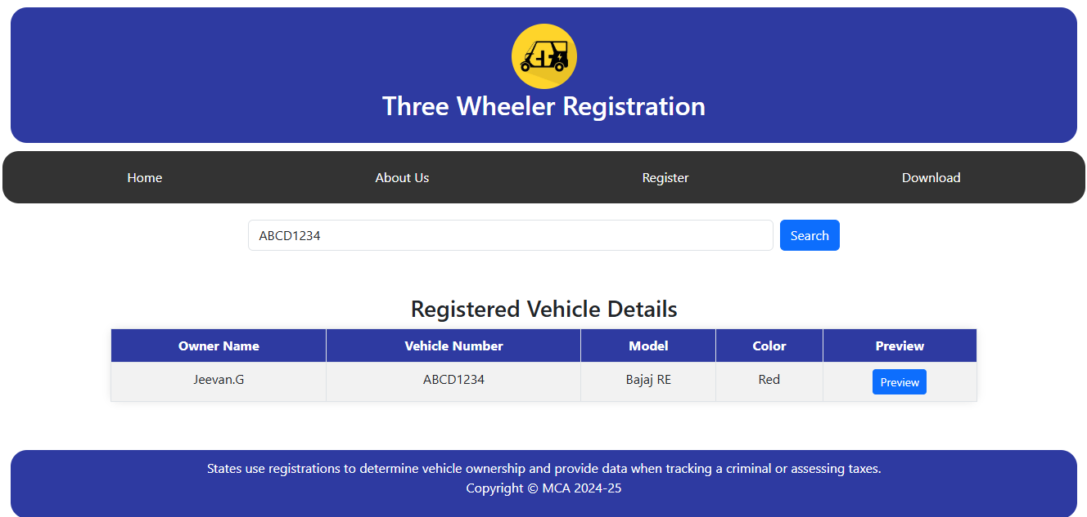

*Figure 4: Search and Preview*

This page is part of the **Three Wheeler Registration** system and is designed for searching and displaying registered vehicle details. Users can enter a vehicle number in the search bar and click the **Search** button to retrieve information about the corresponding registered vehicle. **As shown in *Figure 4: Search and Preview***, the results are displayed in a tabular format, including details such as the **owner’s name, vehicle number, model, and color**. Additionally, there is a **Preview** button that likely provides more detailed information or an image of the vehicle when clicked. The process ensures easy access to registration data, helping users verify vehicle ownership and related details efficiently.

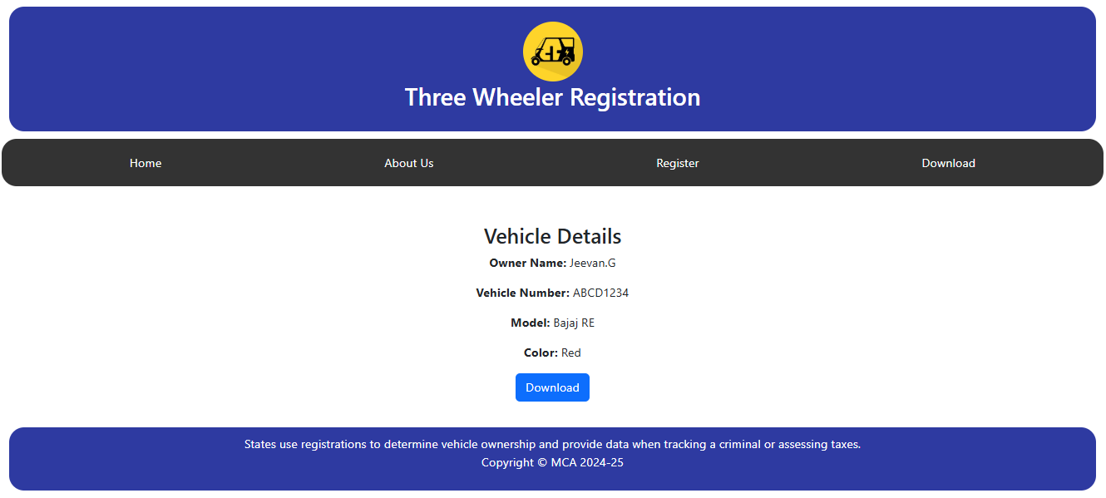

*Figure 5: Preview and Download*

This page provides a detailed view of a registered vehicle's information after the user selects the **Preview** button from the search results. The displayed details include the **owner's name, vehicle number, model, and color**, ensuring users have clear and accurate information about the registered three-wheeler. The design is structured to enhance readability and accessibility. **As shown in *Figure 5: Preview and Download***, the interface includes a dedicated download option that enhances user convenience.

A **Download** button is available, allowing users to save the displayed vehicle details in **PDF format**. This feature ensures easy record-keeping and can be used for official purposes, including verification and documentation. When the user clicks the Download button, a PDF file containing the same structured vehicle details is generated and saved to their device. This functionality is particularly useful for **authorities, vehicle owners, or any entity** that requires proof of registration in a well-documented format. Additionally, the user-friendly interface ensures a seamless experience, making the process of retrieving and storing vehicle information efficient.

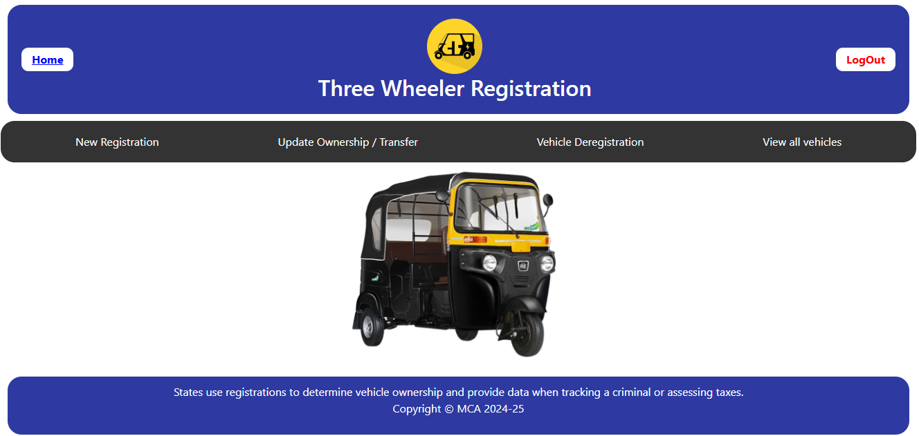

*Figure 6: Admin-Home Page*

The Admin-Home Page of the Three Wheeler Registration system serves as the central hub for managing various administrative functions. It provides authorized administrators with quick access to key operations, ensuring efficient handling of vehicle registration tasks. The page features multiple navigation options, allowing admins to register new three-wheelers, update ownership details, process vehicle deregistrations, and view all registered vehicles. **Figure 5: Admin-Home Page** illustrates how these core functions are organized into an intuitive and accessible interface.

When an admin selects an option, the system redirects them to the relevant section where they can perform specific tasks. For example, clicking "New Registration" leads to a form where vehicle and owner details can be entered, while "Update Ownership / Transfer" enables modification of ownership records. The "Vehicle Deregistration" section assists in removing vehicles from the system, and "View All Vehicles" displays a comprehensive list of registered three-wheelers. Each action is supported by authentication and validation checks to ensure data integrity and security.

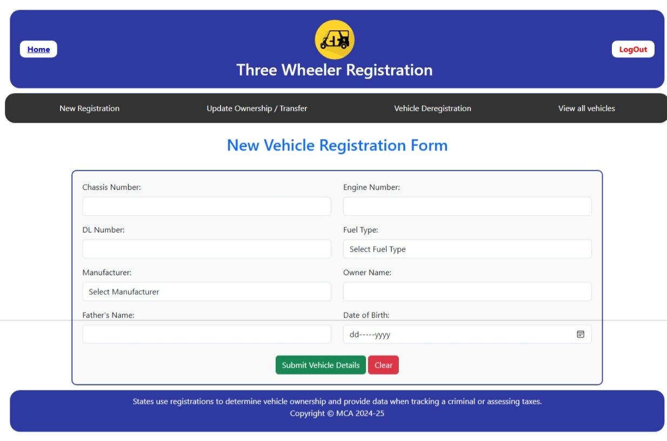

*Figure 7: New-Vehicle Register*

The **New Vehicle Registration Page** is designed to facilitate the registration of three-wheelers by collecting essential vehicle and owner details. This page allows authorized administrators to enter and submit necessary information for a new vehicle's inclusion in the system. The form consists of multiple input fields such as **Chassis Number, Engine Number, DL Number, Fuel Type, Manufacturer, Owner Name, Father's Name, and Date of Birth**. ***Figure 6: New-Vehicle Register*** illustrates the structured layout of the registration form, ensuring clarity and ease of data entry.

When an admin fills in the required details and clicks on the **"Submit Vehicle Details"** button, the system validates the input fields to ensure completeness and correctness. If any mandatory field is missing, an error message prompts the user to enter the necessary information. Upon successful validation, the details are stored in the database, generating a new registration record for the vehicle. Additionally, the **"Clear"** button allows the admin to reset the form, removing all entered data in case of errors or modifications before submission. The streamlined design of this page ensures efficient data entry while maintaining accuracy in the vehicle registration process.

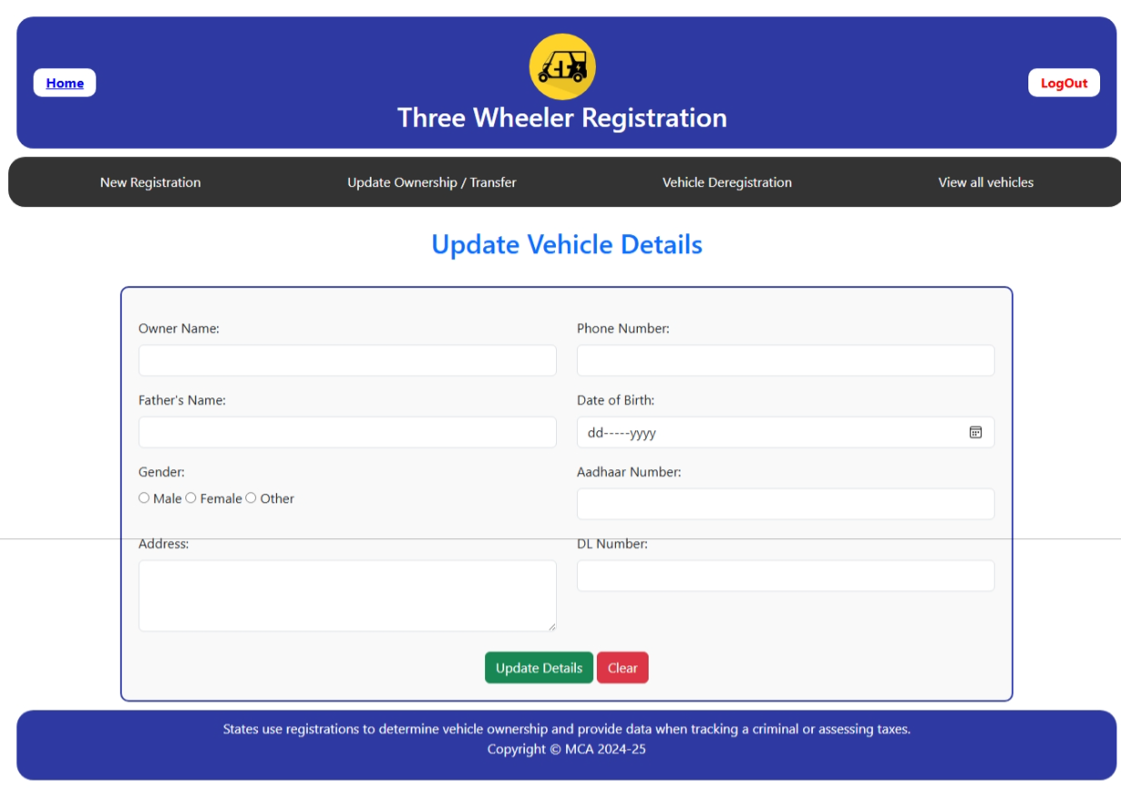

*Figure 8: Update existing details*

The **Update Vehicle Details Page** allows administrators to modify existing records by updating the owner's personal and vehicle-related information. This page ensures that any changes in ownership or corrections to previously entered data are accurately reflected in the system. The form includes input fields such as **Owner Name, Father's Name, Gender, Address, Phone Number, Date of Birth, Aadhaar Number, and DL Number**, enabling comprehensive data updates. ***Figure 8: Update existing details*** illustrates how these fields are structured to facilitate easy modifications while maintaining data integrity.

When an admin enters the updated details and clicks the **"Update Details"** button, the system verifies the input for correctness and completeness. If any required field is left blank or incorrect information is detected, an error message prompts the user to make the necessary corrections. Once successfully validated, the updated details are stored in the database, ensuring that the latest information is available for administrative and regulatory purposes. The **"Clear"** button allows the admin to reset all fields, removing any entered data before submission. This page plays a crucial role in keeping vehicle records accurate and up-to-date, supporting efficient management of three-wheeler registrations.

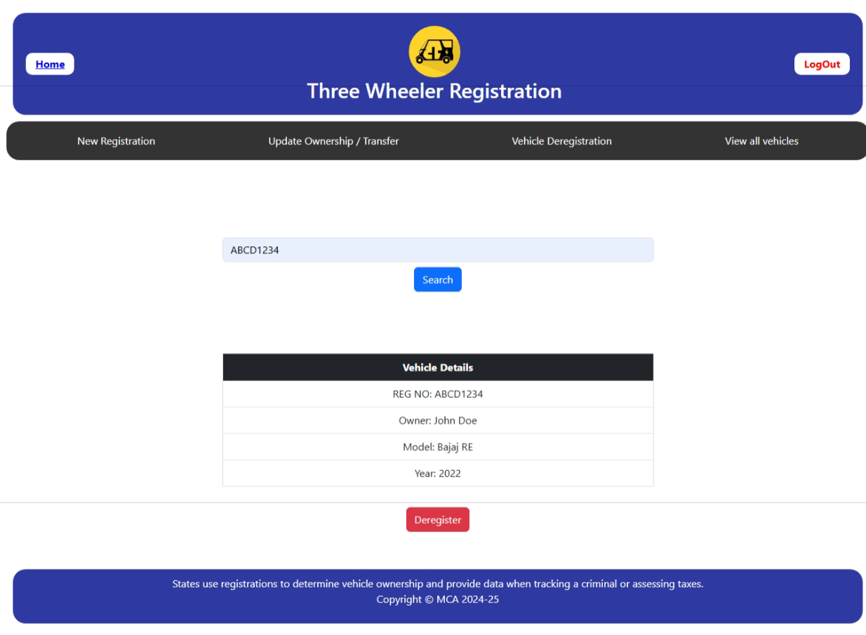

*Figure 9: Search and De-Register*

The page allows users to search for a vehicle using its registration number and deregister it if needed. Users enter the registration number in the input field and click the **Search** button, which triggers the showVehicleDetails() function. This function retrieves the details of the vehicle, including the registration number, owner name, model, and year, and displays them in a structured table format. ***Figure 9: Search and De-Register*** illustrates this functionality, showing the registration number and corresponding vehicle details. Once the details are displayed, users have the option to click the **Deregister** button, which triggers the deregisterVehicle() function. This function removes the displayed vehicle details and shows a confirmation alert stating that the vehicle has been deregistered successfully. The page also includes a logout option, which prompts the user for confirmation before redirecting them to the login page.

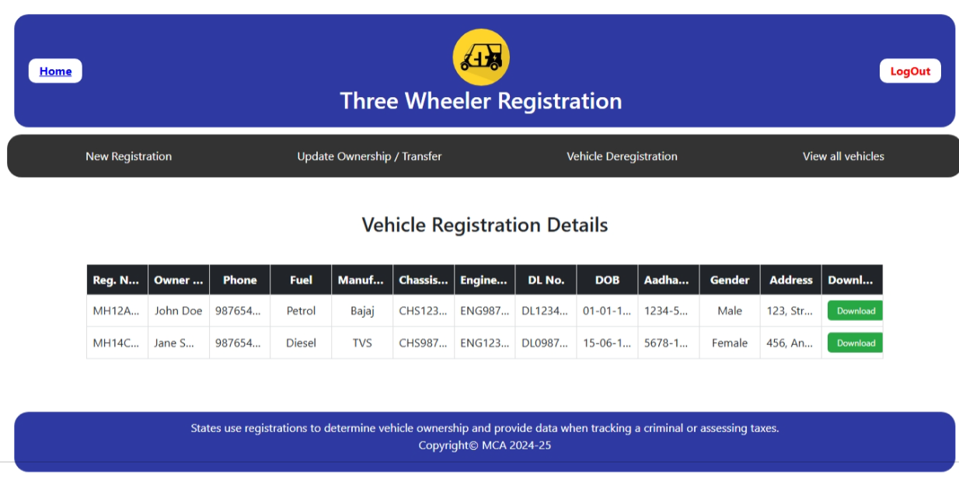

*Figure 10 : Download-All (Admin)*

The page displays a table containing the details of all registered three-wheeler vehicles, including registration numbers, owner details, fuel type, manufacturer, chassis and engine numbers, driving license number, date of birth, Aadhaar number, gender, and address. Each row in the table represents an individual vehicle record. **Figure 10: Download all** illustrates this functionality, where an admin can view the complete list of registered vehicles. The page includes a **Download** button for each record, allowing the admin to download the specific vehicle details. The "Download all" feature is restricted to admin users, ensuring that only authorized personnel can access and store all vehicle registration data. This functionality is crucial for managing vehicle records, verifying ownership, and maintaining an official database for regulatory purposes.